1. Linked lists
2. Singly linked lists
3. Doubly linked lists
4. Circular linked lists
5. Stacks and Queues

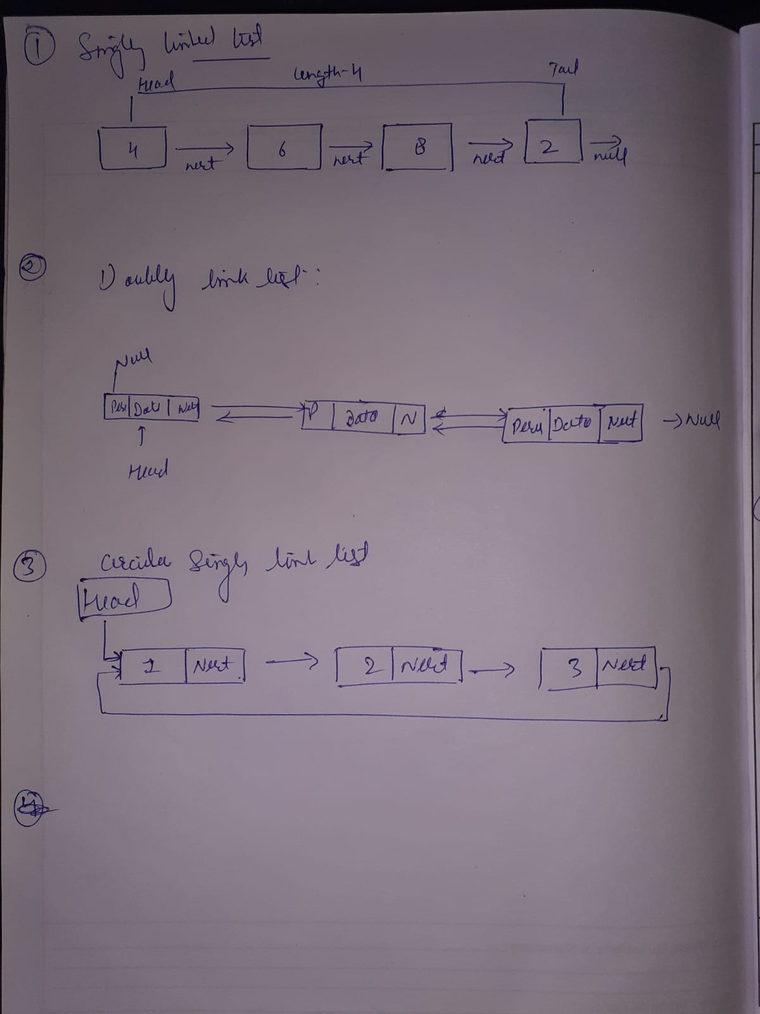

 take array of list apply leaner search.

Take array soreted apply binary search

